Before the End: Three Powerful Practices for Chaplains and Healthcare Professionals to Shift End of Life Conversations.  When  Friday, March 15th, 2019  8:30am – 12:30pm  Where  Providence Willamette Falls Community Center,  519 15th St, Oregon City, OR 97045  WHAT  We have representatives from differing aspects of the end of life journey and beyond coming to share their experience and expertise.  Suggested Donation: Employed: $5,  Students and Retired: $2.50  RSVP: Chaplain Anne Richardson, continuing education chair at chaplainanne@icloud.com or oregon.chaplains@gmail.com  Feel free to invite Social Workers or others you feel would benefit. We have room for 45  HOW  After introductions, we are planning on having rotating break-outs so each one in attendance can have more intimate group time with each of our experts.  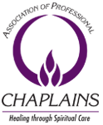 | 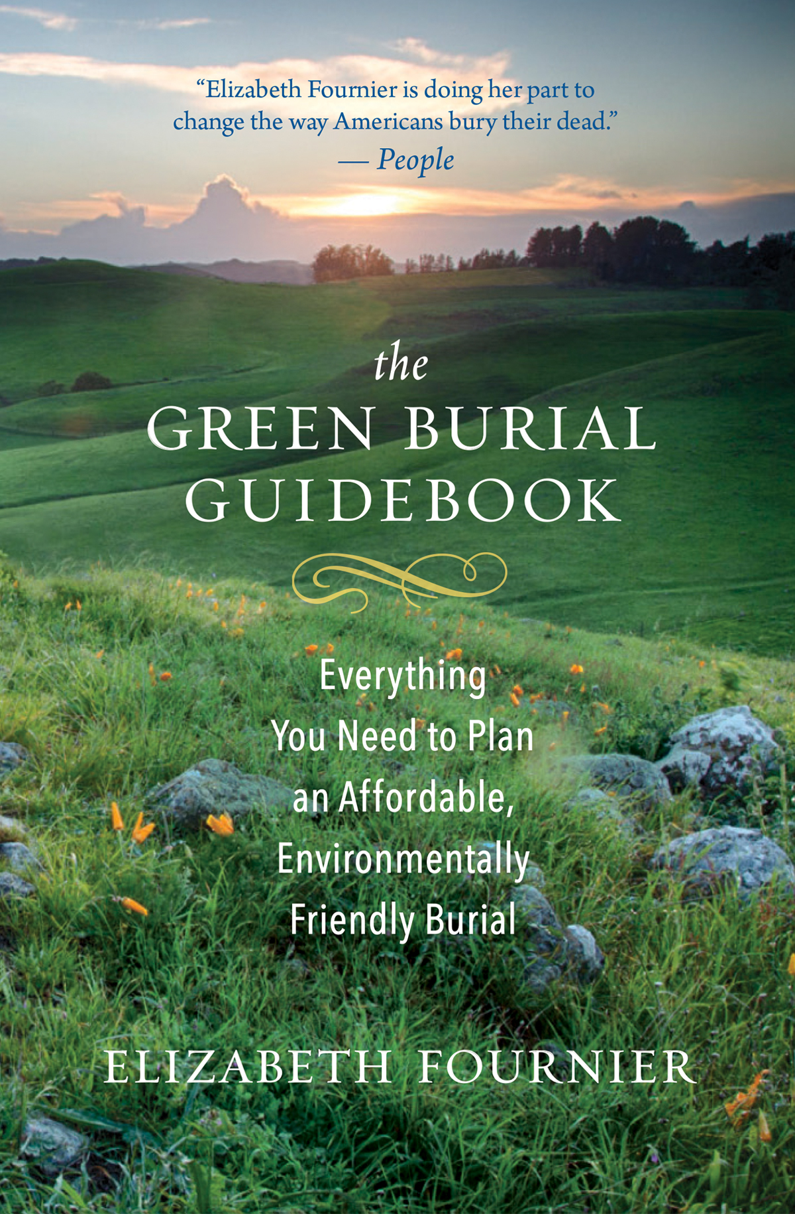  Elizabeth Fournier, green mortician and eco-educator, and author of The Green Burial Guidebook (https://www.cornerstonefuneral.com/), will discuss home funerals, natural burials, and alkaline hydrolysis.  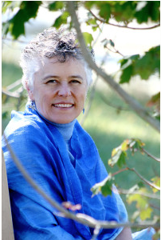  Heather Michet, ceremonialist (https://irishealingarts.com/songstress/), will share about the healing power of ceremony and song in honoring the beloved.  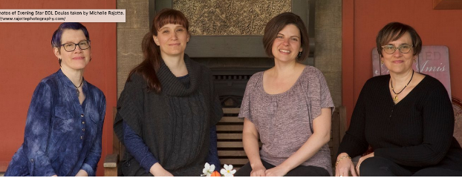  Evening Star End of Life Doula Services, LLC (https://eveningstar-eol-doula.com/) will share how EOL doulas come alongside families whether or not they are on hospice or palliative care.  The School of Music and the University Arts and Entertainment Council

